Experiment No: 3

Title: Implement control structures and form validation; create a grading system based on user-entered marks.

Software/Tools Required: Visual Studio Code (or any text editor), Web Browser (Google Chrome, Microsoft Edge, Firefox, etc.)

Theory:
JavaScript provides different control structures and variable declaration methods to build interactive web applications.
1. if-else Statement
- Used to make decisions based on conditions.
- Executes different blocks of code depending on whether the condition is true or false.
2. switch Statement
- Used when multiple conditions need to be checked.
- Executes the matching case based on the given expression.
3. Loops
- for: Repeats code for a fixed number of iterations.
- while: Repeats code while a condition is true.
- do-while: Executes the code at least once before checking the condition.
4. Form Validation
- Ensures that user inputs are valid before processing.
- Checks for empty fields, valid ranges, and correct data types.
Student Grading System
A Student Grading System is a JavaScript application that accepts student details and marks, validates the input, calculates the total and percentage, assigns grades using control structures, and displays the final result dynamically.

Output:

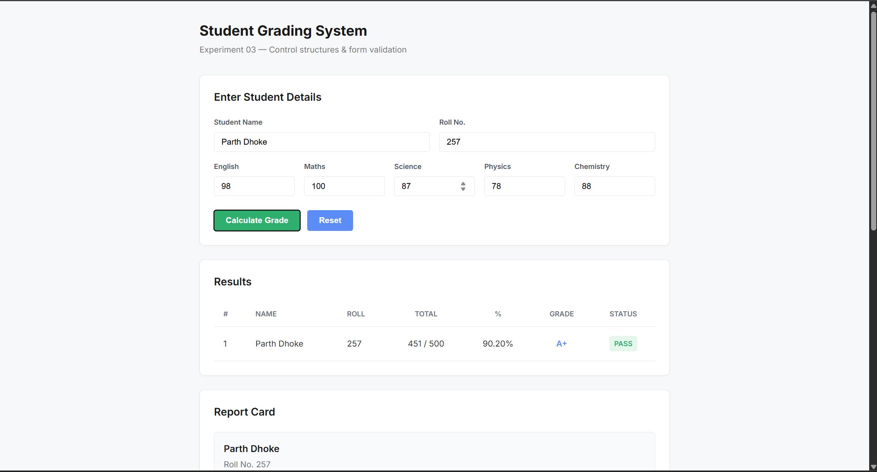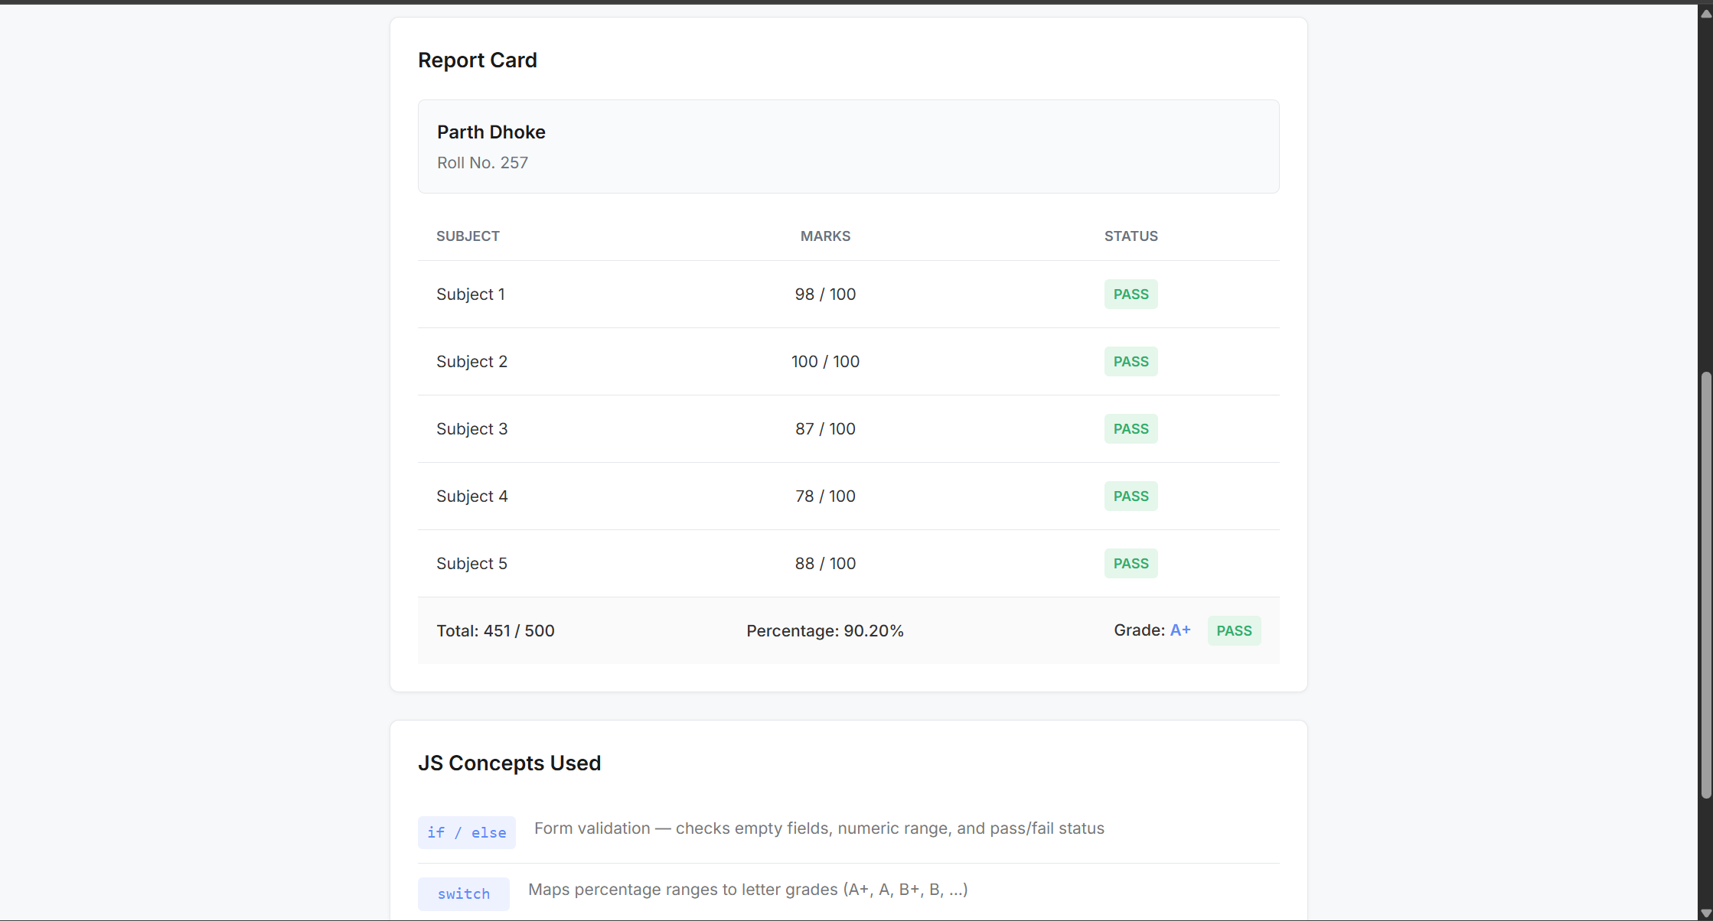

Result/Conclusion:
The experiment was successfully completed. The concepts of var, let, and const were understood and implemented. Template literals were used to display formatted output, and destructuring simplified data extraction from objects. A billing calculator was successfully developed to accept user input, calculate the bill with GST, and display the final amount accurately.

Case Study:
